**AKGEC/IAP/FM/02**

**Ajay Kumar Garg Engineering College, Ghaziabad**

**Department of ECE**

**Sessional Test-2**

Course: B.Tech Semester: V

Session: 2017-18 Section: EC-1, EC-2, EC-3, EI

Subject: Control System-I Sub. Code: NIC-501

Max Marks: 50 Time: 2 hour

***Note***: Answer **all** the sections.

**Section-A**

1. Attempt **all** the parts. **(5x2 =10)**
2. Explain Eigen value and Eigen vector.
3. What is Controllability and Observability?
4. Explain the difference between transient response and steady state response of a control system.
5. Mention the nature of transient response of second order control system for different types of

damping ratios.

5. Find and explain the type of open loop transfer function for the system



**Section-B**

1. Attempt **all** the parts. **(5x5 = 25)**

6. What is State Transition Matrix? Give Laplace transform method of computing the State

Transition matrix. Also, give the properties of state transition matrix with proof.

7. The figure below shows mechanical system and its response when 20N of force is applied to the

system. Calculate the value of M and B.

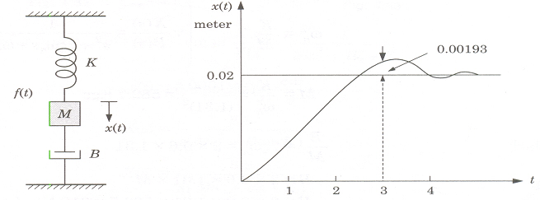

8. The open loop transfer function of a unity feedback system is and damping

ratio, ξ = 0.4. Determine the K and the steady state error for ramp input.

9. What is transfer function matrix? Obtain the transfer function Y(s)/U(s) for the state space

representation



10. Derive the second order system response subjected to unit step input for the following value of

damping ratio ξ ( (i) 0 < ξ < 1 (ii) ξ = 0.

**Section-C**

1. Attempt **all** the parts. **(2x7.5 = 15)**

11. Give time domain specifications. Derive the expressions for rise time, peak time and peak overshoot for a second order system subjected to unit step input?

12. Explain state, state variable and state vector. What are the advantages of state space techniques?

Find the state equation and output equation for the system given by

